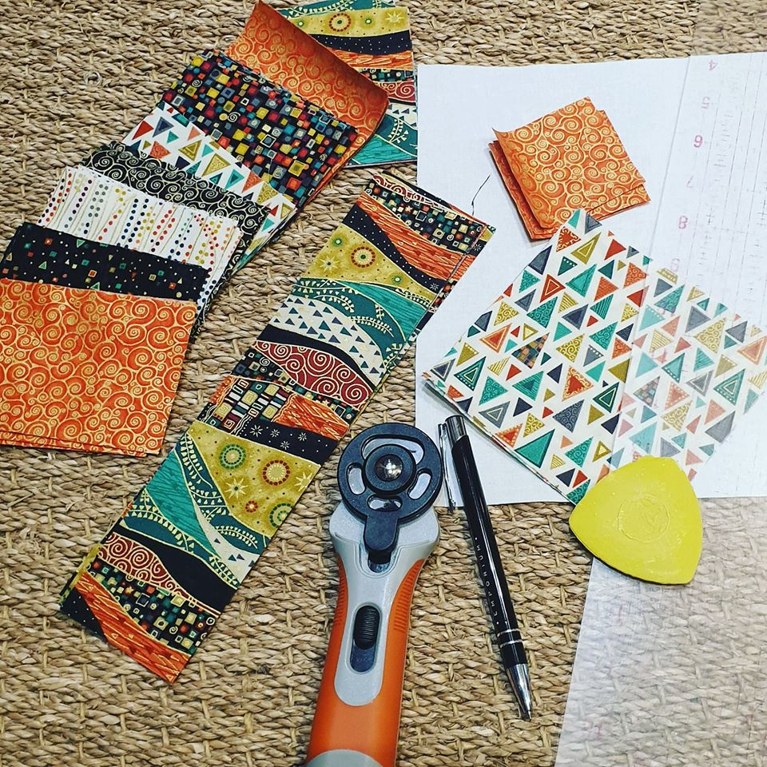
Folded Star Cushion
What you need:
1 x 10 inch x 10 inch square
8 sets of 8, 3 inch x 4 inch rectangles total 64
4 x 10.5 inch x 2.5 inch stripes
2 x 5 inch squares
4 x 2.5 inch squares
You’re also need the following
tailors chalk
ruler
long pins
walking foot
iron
Sew with a ¼ seam allowance
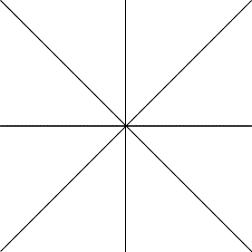
Instructions
- Draw lines on the 10” square
through the centre divining it into 8 equal sections.

- Choose your order for your 8 sets of 3”x4” pieces. The order must be the same for each set to create the matching star.
- Press with an iron a ¼ inch on the longer side of the 3” x 4” inch rectangles on all 64 pieces.
- Place the 1st piece of one of the sets on the 10” x 10” square so that the folded edge is facing down and the right side of the fabric is facing you. Start on the centre line and make sure the middle of the 3” x 4” is central over the lines starting in the middle. Lay each other piece from that one set evenly so that the last piece finishes at the edge of the 10” square.

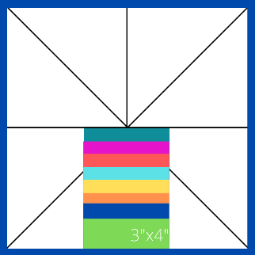

- Start your next set directly opposite the last one and make sure the first piece is touching the central line.
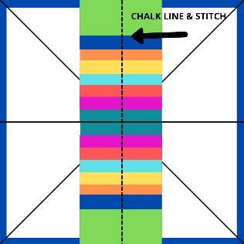

- Draw a line with your chalk directly through the middle of your placed fabric. See the picture above.
- Using a walking foot on your machine sew a straight line from one end to the other centrally following your chalk line.
- Repeat steps 4 to 7 for all your lines drawn on your 10 x 10 inch square, taking care not to sew over the previous sets.
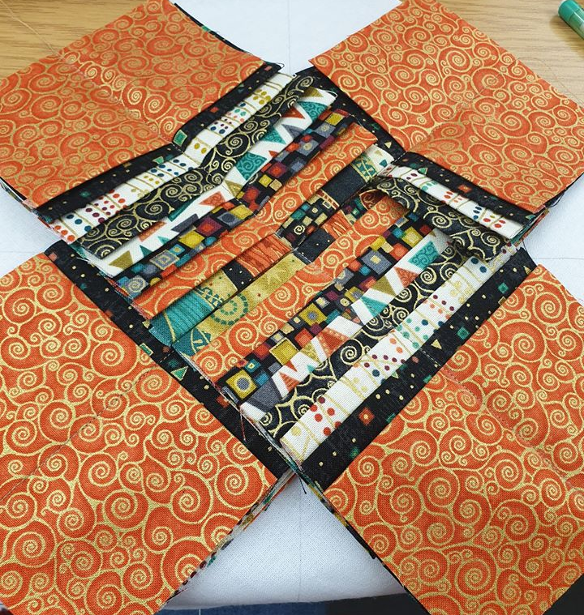
Using fabric clips to hold the sewn fabric out of the way really helps!
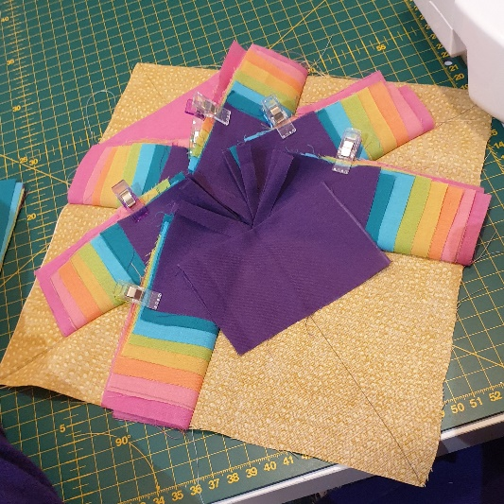

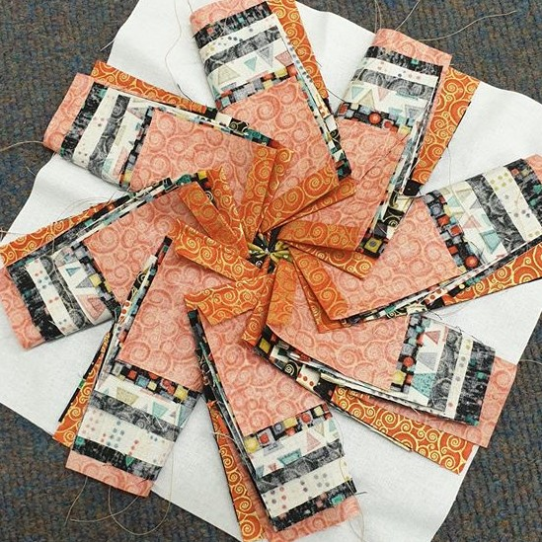
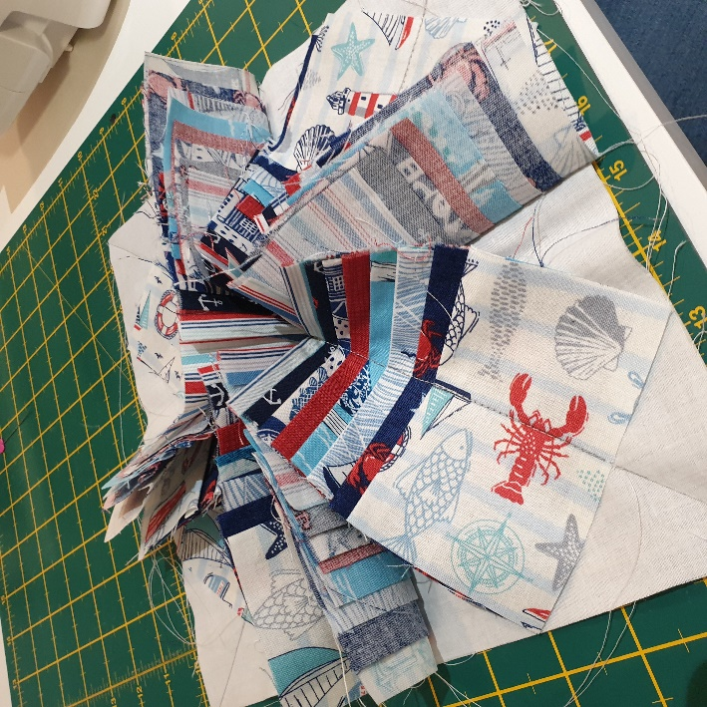
Your 10” square should now look like these above once all 8 sections have been sewn on the lines.

- Fold the 1st central piece of fabric behind into a triangle then fold forward to make a smaller thinner triangle. Do the same with the adjacent partner from the adjacent set. Pin to hold in place. Secure with a straight stitch mid way down from the top of the triangle.
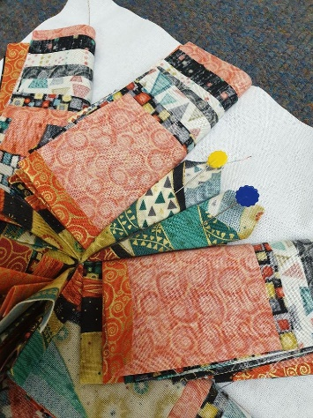

Stitch here to hold both in place
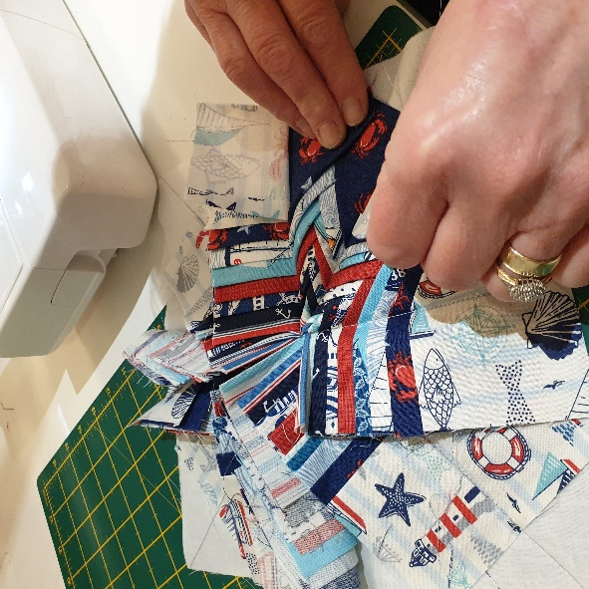

- Starting at the next piece of fabric from the set fold each level back on itself to create a triangle. Remember to always start at the same side, secure in place with stitches once a few folds are done. Repeat step 10 for the rest of the set.
- Continue steps 9 and 10 till all the levels are complete.
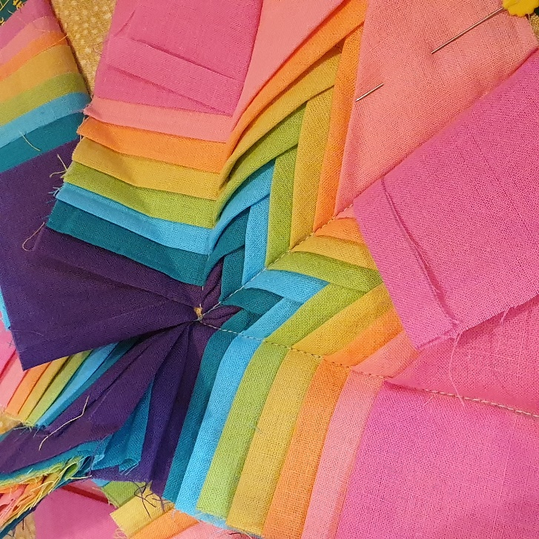
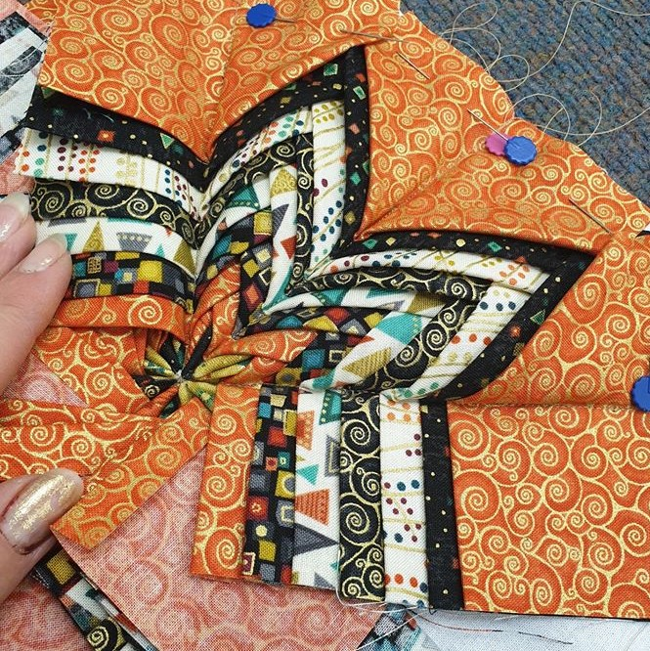
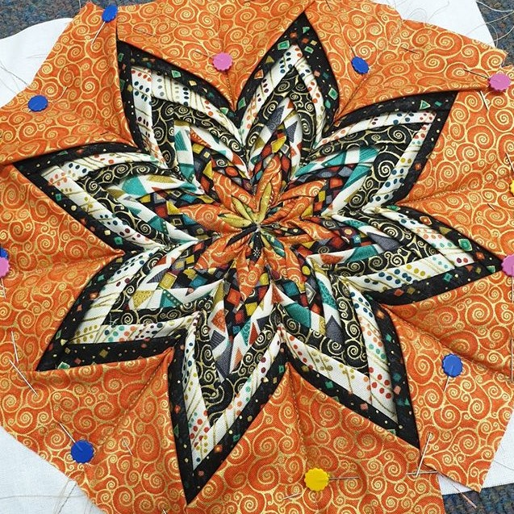

- Take the 5” squares and fold in half to make a triangle. Cut along the fold line so you now have 2 triangle pieces. Repeat this step on the other 5” piece.
- Fold and press ¼ inch of the longer edge of the triangle pieces, place over the edge of the last 8th piece where you can see your 10 x 10 inch square visible. Stitch in place
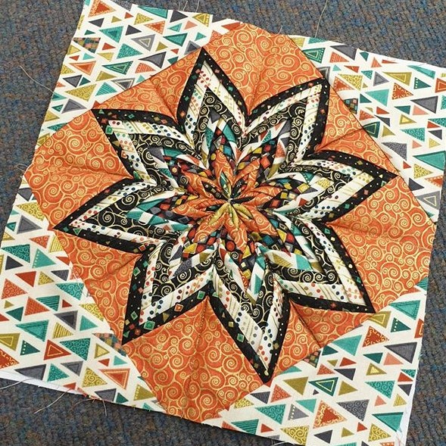

- Trim off where necessary to neaten all the edges so you have a nice neat square.
- Sew a 10.5” stripe to two opposite sides of the block using a ¼ seam allowance.
- Attach a 2.5” square to each end of the remaining 10.5” pieces. Line up on other sides of your block making sure your seams match.
- Lightly press your block.

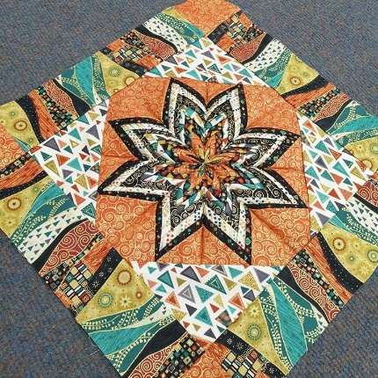

Congratulations you have completed your folded star block!!
This can now be made into a cushion, make more blocks and create a table runner or add the block to a quilt. Many many options.

